**Project Design Phase-II**

**Technology Stack (Architecture & Stack)**

|  |  |
| --- | --- |
| Date | 19 October 2022 |
| Team ID | PNT2022TMID52614 |
| Project Name | Project – Containment zone alerting app |
| Maximum Marks | 4 Marks |

**Technical Architecture:**

The Deliverable shall include the architectural diagram as below and the information as per the table1 & table 2

**Example: Order processing during pandemics for offline mode**

**Reference:** [**https://developer.ibm.com/patterns/ai-powered-backend-system-for-order-processing-during-pandemics/**](https://developer.ibm.com/patterns/ai-powered-backend-system-for-order-processing-during-pandemics/)

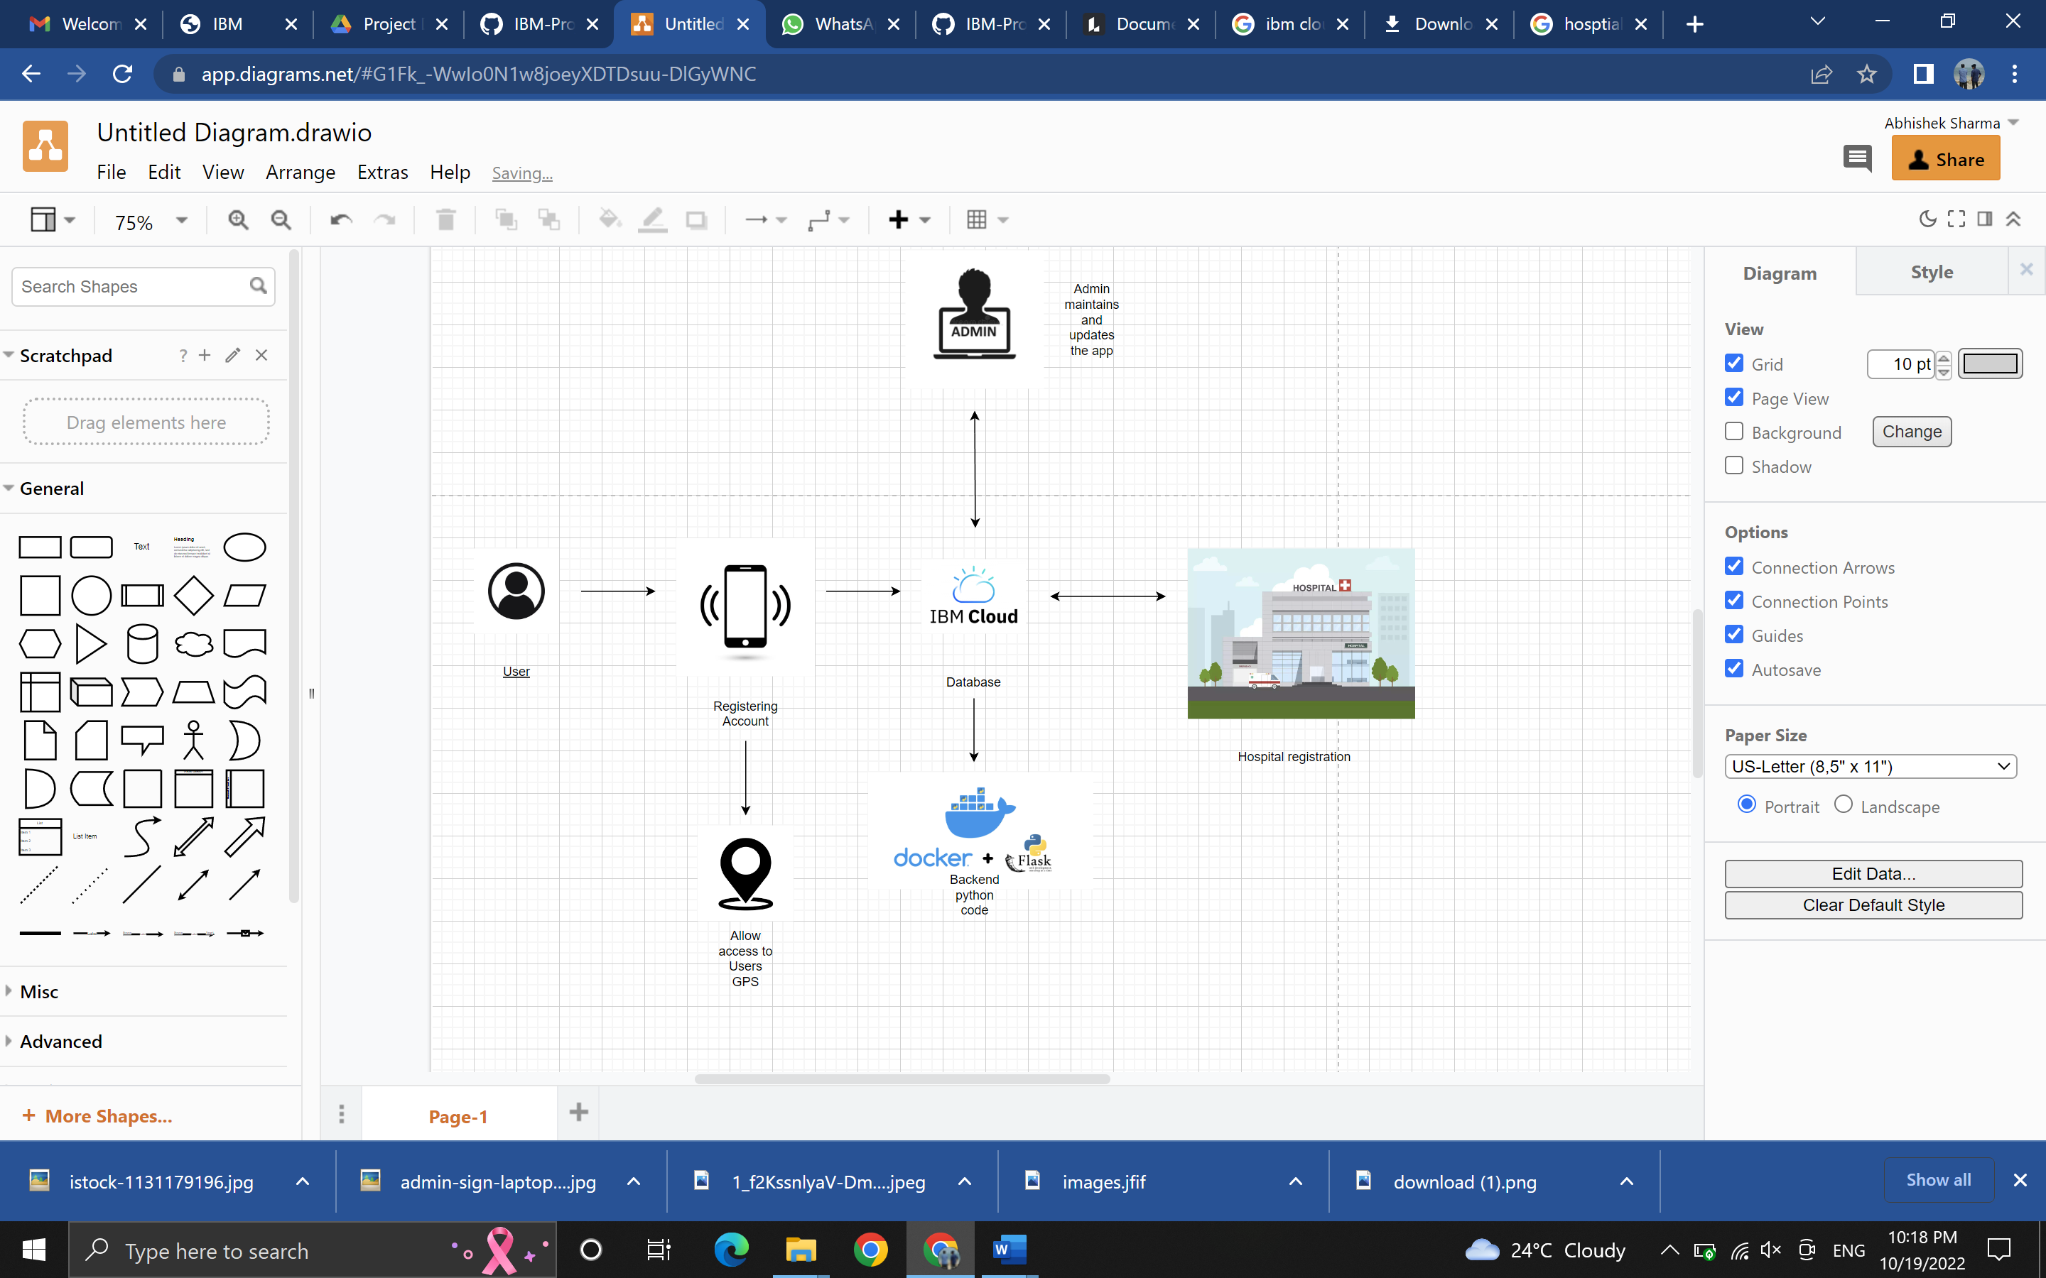

**Table-1 : Components & Technologies:**

|  |  |  |  |
| --- | --- | --- | --- |
| **S.No** | **Component** | **Description** | **Technology** |
|  | User Interface | Access through mobile app. | HTML, CSS, JavaScript Flask |
|  | Application Logic-1 | Application interface | Python Flask |
|  | Application Logic-2 | AI assistant that gives medical services | IBM Watson STT service |
|  | Application Logic-3 | App access send grid for location and sending alert if needed. | Send grid |
|  | Database | Supports database to store users info for the app. | IBM DB 2 |
|  | File Storage | File storage in cloud and local storage | IBM Block Storage or Other Storage Service or Local Filesystem |
|  | External API-1 | With a help of REST API getting details like location of containment zone and many more | REST API |
|  | Deep Learning Model | Algorithm for case information by hospitals. | Aadhar API, etc. |
|  | Infrastructure (Server / Cloud) | IBM based server | Local, Cloud Foundry, Kubernetes, etc. |

**Table-2: Application Characteristics:**

| **S.No** | **Characteristics** | **Description** | **Technology** |
| --- | --- | --- | --- |
|  | Open-Source Frameworks | Used for backend coding. | Flask |
|  | Security Implementations | Encryption of user data to keep safe from unauthorised people. | Encryption |
|  | Scalable Architecture | Users are also provided services and awareness to people. | IBM Cloud |
|  | Availability | Facts from doctor , contained zone, medical details if required | IBM Watson Assistant |
|  | Performance | Algorithm to update the details of containment zone | Geo - fence |

**References:**

[**https://c4model.com/**](https://c4model.com/)

[**https://developer.ibm.com/patterns/online-order-processing-system-during-pandemic/**](https://developer.ibm.com/patterns/online-order-processing-system-during-pandemic/)

[**https://www.ibm.com/cloud/architecture**](https://www.ibm.com/cloud/architecture)

[**https://aws.amazon.com/architecture**](https://aws.amazon.com/architecture)

[**https://medium.com/the-internal-startup/how-to-draw-useful-technical-architecture-diagrams-2d20c9fda90d**](https://medium.com/the-internal-startup/how-to-draw-useful-technical-architecture-diagrams-2d20c9fda90d)